**BIGINELLI REACTION: AN OVERVIEW**

**ABSTRACT**

Biginelli reaction is an acid-catalyzed one-pot synthesis of 3,4-dihydropyrimidin-2(1H)-ones (DHPMs) using aldehyde, active methylene compound and (thio)urea as starting material and in the presence of certain ionic catalysts such as 1-n-butyl-3-methylimidazolium tetrafluoroborate (BMImBF4) or hexafluorophosphorate (BMImPF6) as catalysts under solvent-free and neutral conditions. DHPMs are considered as vital biological scaffolds due to their involvement in various medicinal activities. This present report covers the summary of recent progress in designing and developing Biginelli reaction strategies particularly the greener strategies with higher yields, short times and simple workup.

**INTRODUCTION**

Multicomponent reactions (MCRs) contain an aggregate of three or extra reactants in a single vessel to produce a final product with features of all the reactant components. Biginelli reaction is the well known reaction among the multi-component reaction1. It produced 3,4-dihydropyrimidin-2(1H)-ones/thiones that have valuable biological activities and were developed by Pietro Biginelli in 1893. Biginelli reactions, and in general one pot multicomponent reactions, are a valid tool to build complex molecules with simplicity and brevity. In fact, they allow the formation of target products to occur in a single operation from three or more reactants, with high atom-economy, bond-forming efficiency, compatibility with green solvents, and under mild conditions. For these reasons, they may be well classified as sustainable and eco-compatible methodologies2.

Dihydropyrimidinones are taken into consideration as essential organicscaffolds because of their involvement in diverse medicinal activities. As an end result of the huge usage of variousBiginelli adducts in various fields the chemistry of the Biginelli motifs has been explored in drug discovery. The classical model of Biginelli reaction involves the acid-catalyzed, three-component reaction between benzaldehyde; ethyl acetoacetate (EAA), and urea in ethanol at reflux condition inciting the formation of Biginelli adduct2.(Scheme-1)

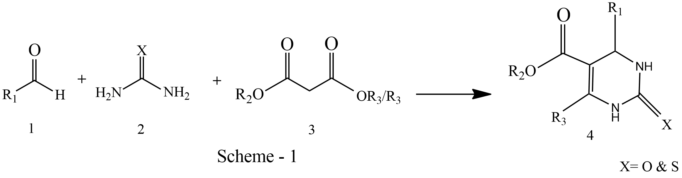

DHPMs had been seen to flaunt a huge spectrum of biological activities including antimalarial, antileishmanial, antitubercular, antiviral, antidiabetic, antiproliferative, anticancer, calcium channel inhibition, antioxidant, antimicrobial, antitumour, anti-inflammatory, antihypertensive, antineoplastic activities, etc2. A number of functionalized DHPMs have been found to be potent calcium channel blockers, anti-HIV agents3

* **Advancements in Classical Biginelli Reaction**.

In the classical Biginelli conditions, low yields and difficult isolation of the products are the main drawbacks because of the strongly acidic conditions, particularly when substituted aromatic or aliphatic aldehydes and thiourea were employed. Recently, Sandhu et al. reported a broad perspective over different catalysts employed for Biginelli reaction. A variety of catalysts claim enhancements in modified Biginelli reactions, involving Lewis acids, such as halides, triflates, and other salts of many metals, ionic liquids, biocatalysts, clays, minerals, alumina, silica, cyclodextrins, heteropolyacids, heteropolyanions, organocatalysts, polymers as catalysts, etc4

Due to their important biological activities, several improved protocols have been reported. The numerous homogeneous catalysts, heterogeneous catalysts, ionic liquid liquids as a solvent or catalyst and immobilized IL over solid support are reported for this reaction. The recently published reviewed by Patil et al4 extensively summarized the research work especially on heterogeneous catalysts for Biginelli reaction and Panda et al summarized green perspective approach for Biginelli reaction including microwave, water and ethanol as solvents, solvent free conditions, ionic liquids which included development occurred before4 2012.

* **POSSIBLE MECHANISMS OF BIGINELLI REACTION**

**Pathway-1:** Iminium route involves condensation between aldehyde and urea to give rise to an iminium intermediate, which undergoes a nucleophilic addition with B-keto ester leading to DHMP (Scheme-2)

**Pathway-2**: Enamine route is based on condensation between urea and B-keto ester leading to a protonated enamine intermediate, which subsequwntly reacts with aldehyde to give rise to the DHMP

**Pathway-3:** Knoevengel type reaction mechanism occurs between aldehyde and B-keto ester results in the formation of a carbenium ion intermediate, which reacts with urea to afford the DHMP.

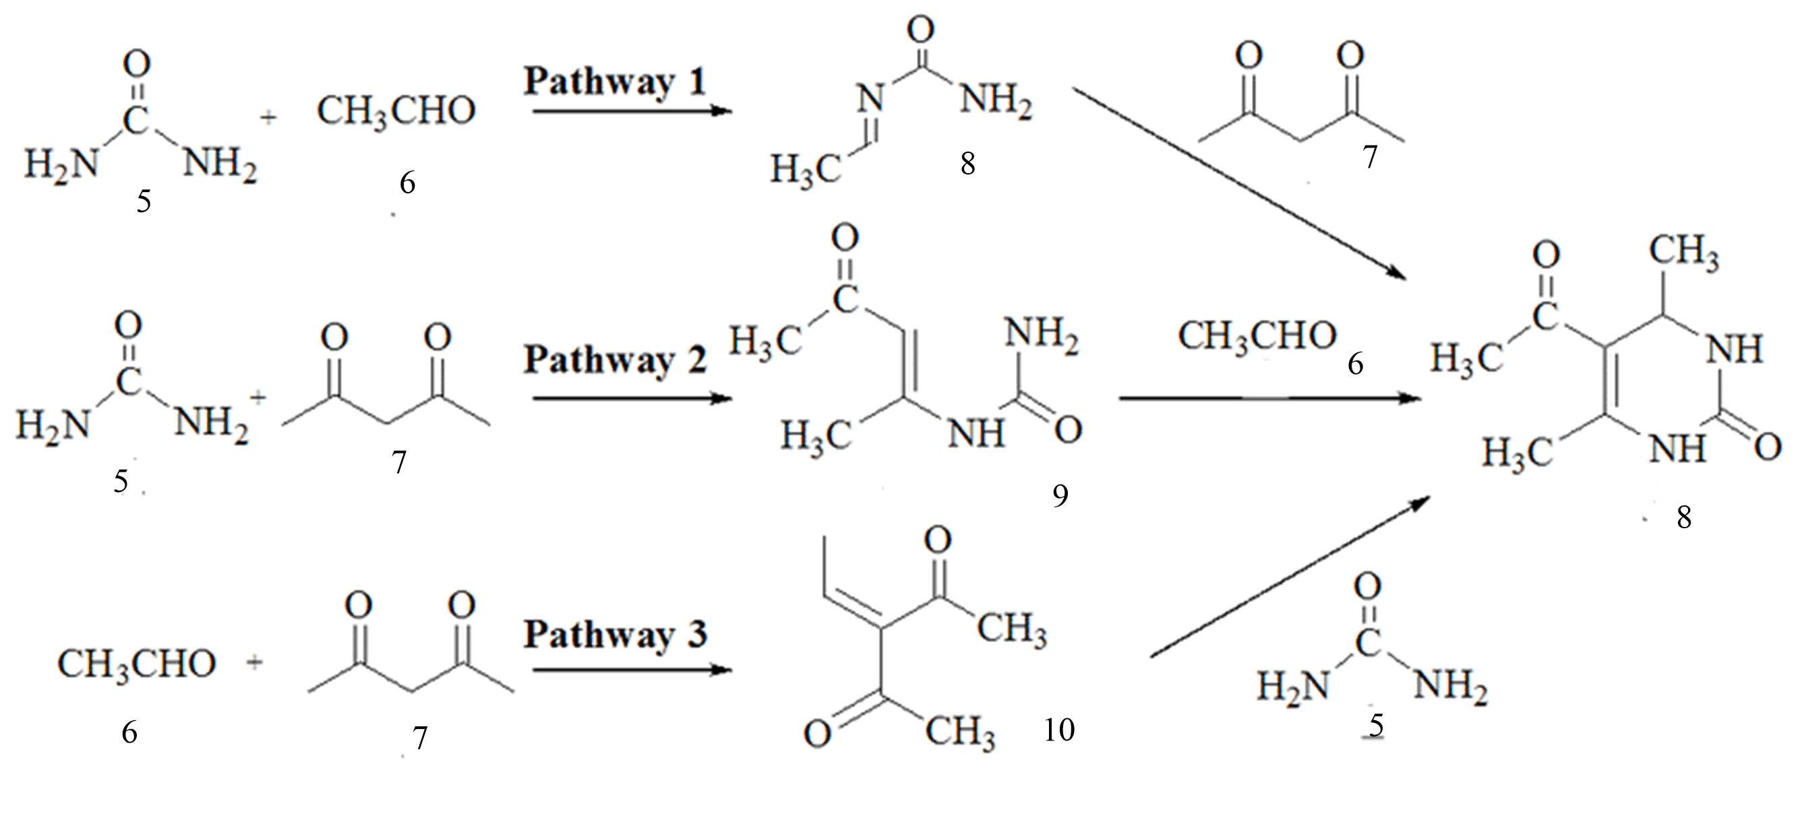

Scheme-2

1. **Ionic liquids catalyzed Biginelli reaction under solvent-free conditions**

Ionic liquids are the organic cations and inorganic or organic anions. They have unique properties such as non volatility, high thermal stability, ion pairing effect and can be recyclable. Ionic liquids showed good catalytic activity as a solvent and catalyst towards the synthesis of dihydropyrimidones/thiones in a very short reaction time. The ion pairing effect of ionic liquids not only improved the yield of product but stabilized the reaction intermediates in effective way5.

J Peng and Y Deng discovered a new approach involves the use of room temperature ionic liquids based on 1-n-butyl-3-methylimidazolium tetrafluoroborate (BMImBF4) or hexafluorophosphorate (BMImPF6) as catalysts for the Biginelli condensation reaction under solvent-free conditions. 1-n-Butyl-3-methylimidazolium tetrafluoroborate (BMImBF4) and hexafluorophosphorate (BMImPF6) ionic liquids were respectively, synthesized according to the procedures reported in previous literatures6.

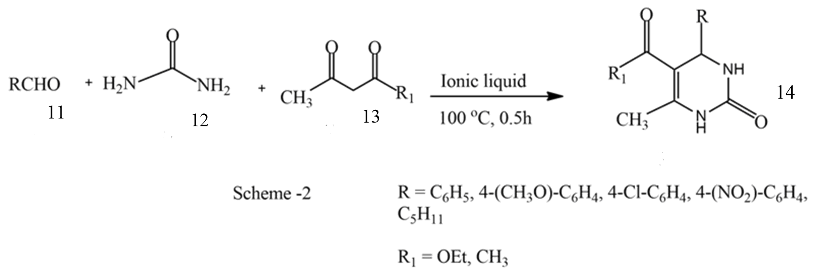

Scheme-3

The condensation reaction of benzaldehyde, ethyl acetoacetate in stoichiometric ratio and urea in slightly excess amount was tested in the presence of different amounts of BMImBF4 at 100°C without any additional solvent (Scheme-3). Isolated yields of 85, 92 and 95%, respectively, could be achieved after the reaction had only proceeded for 30 min. This indicates that the conversion was increased with increasing amounts of ionic liquid with 0.4 mol% of BMImBF4 as catalyst, aromatic aldehydes with either electron-donating or electron withdrawing substituents were also used as one of the substrates. It can be seen that all reacted very well and the yields achieved from the aromatic aldehydes with electron-donating substituents were slightly higher than aromatic aldehydes with electron withdrawing substituents6.

Under the same reaction conditions n-hexylaldehyde, which replaced the aromatic aldehyde as one of the substrates, was tested and 4-n-pentyl-5-(ethoxycarbonyl)-6-methyl-3,4-dihydropyrimidin-2(1H)-one was produced in 93% yield. This shows that aliphatic aldehydes exhibit analogous behavior to that of aromatic aldehydes. The catalytic performances of two kinds of quaternary ammonium salts used as catalyst were also tested (BMImCl & n-Bu4NCl). Low reaction yield was obtained, and the reaction of Biginelli condensation could almost not be observed when the BMImCl (1-n-butyl-3-methylimidazolium chloride) and n-Bu4NCl was used as catalyst, respectively. This indicated that both cation and anion in the ionic liquids played an important role as the catalyst towards the Biginelli condensation. 1-Sulfopyridinium chloride [Pyridine-SO3H]Cl as ionic liquid catalyst showed high catalytic activity for the synthesis of dihydropyrimidones/thiones in solvent-free conditions at 80°C6

The main advantages of this methodology are:

(1) Relatively simple catalyst system

(2) Shorter reaction times

(3) Higher yields

(4) Free of organic solvent

(5) Easy synthetic procedure.

1. **A Brønsted acid catalyzed enantioselective Biginelli reaction:**

The stereogenic center greatly influences the biological activity of dihydropyrimidines. For example, the R enantiomer of dihydropyrimidine (Fig.1), an antihypertensive agent, is more potent than the S enantiomer. Consequently, obtaining enantioenriched materials is essential to increase potency and application range in drugs. Several enantioselective synthetic protocols have been developed over the years7.

Zhu first described an asymmetric catalytic Biginelli reaction with a chiral ytterbium catalyst, providing dihydropyrimidines in high yields with excellent enantioselectivities. The chiral catalyst (−)-4,5-dimethyl-3,6-bis(o-tolyl)-1,2-benzenedisulfonimide (Fig. 1) is an efficient Brønsted acid chiral catalyst in Strecker and Mannich reactions. Biginelli reactions between aromatic aldehydes, thiourea or urea and ethyl acetoacetate carried out in the presence of the chiral catalyst8 (Scheme-4)

Fig - 1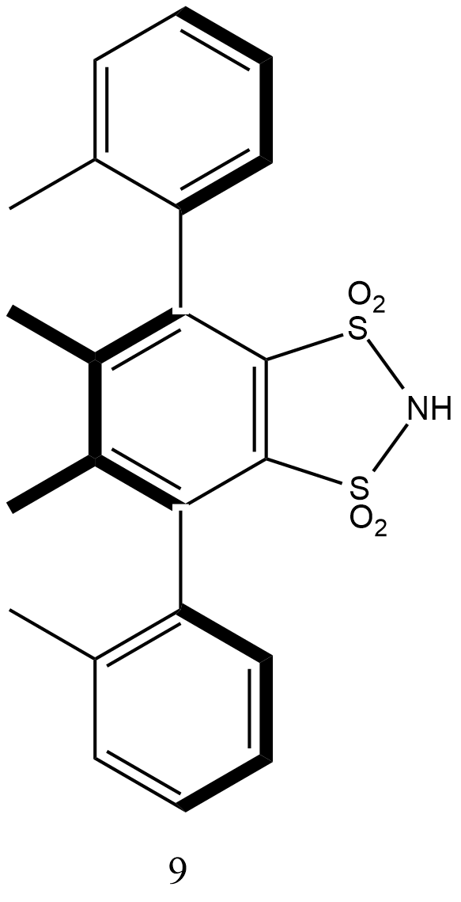

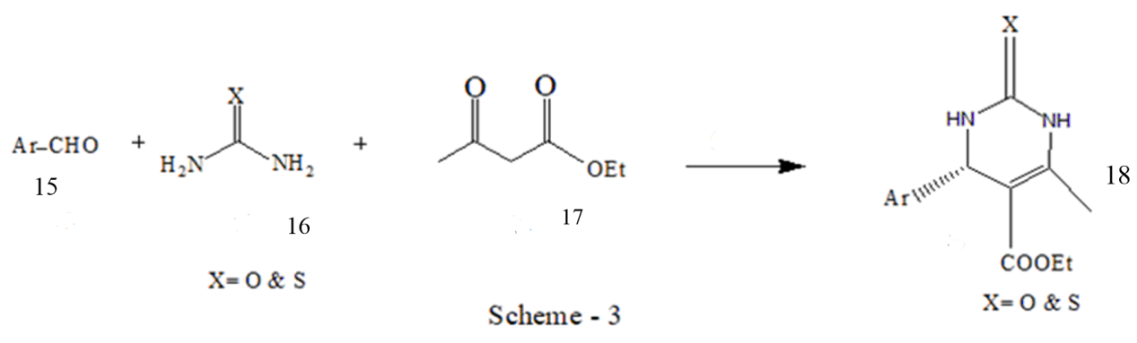

Scheme-4

The model reaction between benzaldehyde 15, thiourea 16 and ethyl acetoacetate 17 was initially studied in the presence of a catalytic amount of (Fig.1) under varying conditions. The best result was obtained under neat conditions, under heating at 50 °C and in the presence of 5% mol of 1, which gave target 18 in excellent yield and enantioselectivity. It can be easily stated that they have proposed a versatile, sustainable, green and convenient synthetic protocol that easily furnished adduct 18.

1. **Asymmetric Biginelli Reaction Catalyzed by Silicon, Titanium and Aluminum Oxides**

The asymmetric Biginelli reaction was investigated in the presence of N-[(2S,4R)-4-hydroxyprolyl]-(S)-1-phenylethylamine as chiral inducer and silicon, titanium or aluminum oxides (individual and mixed bulk and nanosized) as heterogeneous catalysts. Nanosized metal oxides can increase the stereocatalytic activity of some proline derivatives. In particular, nanosized SiO2–ZrO2, obtained by the sol–gel method, enhance stereoselectivity of the Biginelli reaction, carried out in the presence of N-[(2S,4R)-4-hydroxyprolyl]-(S)-1-phenylethylamine trifluoroacetate. It has been established that enantiomeric excess (ee) of the Biginelli reaction products obtained under heterogeneous catalysis in the presence of chiral inductor depends on the nanooxide nature9.

In the stereoselective synthesis of compound C (Scheme-5) aluminum and silicon oxides proved to be the best catalysts among bulk oxides; they increased yields of the target product from 29 to 33–45 %, and ee values, from 39 to 59–60 %. When going from bulk to nanosized aluminum and silicon oxides, it has been noted that a more significant enhancement in both chemo- and stereo selectivity10.

* **Role of oxide catalysts in the asymmetric Biginelli reaction**

Apparently, the key role of oxide catalysts in the asymmetric reaction involving inductor B is the development of additional steric control in the react state, which favors the formation of (R)-enantiomer of compound C. Moreover, the degree of influence depends on the nature of oxides (Ti, Al, Si, individual or mixed), their dimensions (bulk or nanosized particles), and the order of mixing of reagents. It has been demonstrated for the first time that not only nanosized, but also bulk (commercially available) oxides of Ti, Al, Si can enhance the efficiency of chiral inductor B in the Biginelli reaction9.

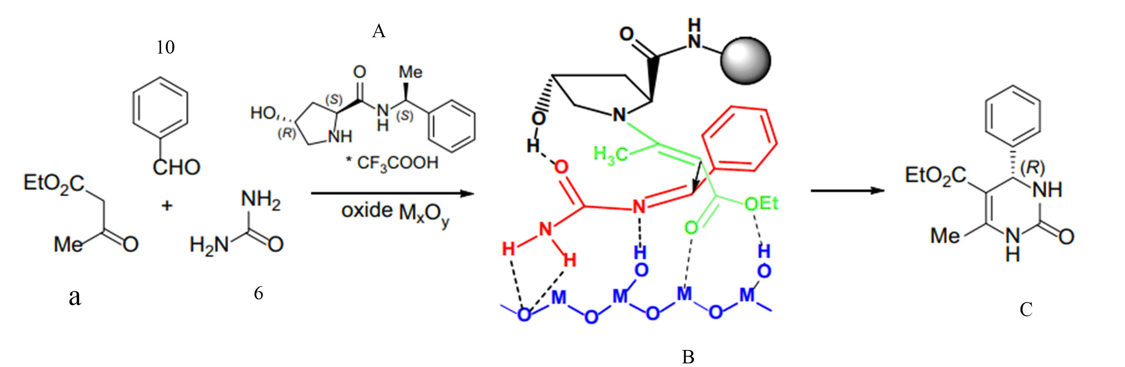

Scheme-5

1. **Highly Enantioselective Biginelli Reaction of Aliphatic Aldehydes Catalyzed by Chiral Phosphoric Acids**

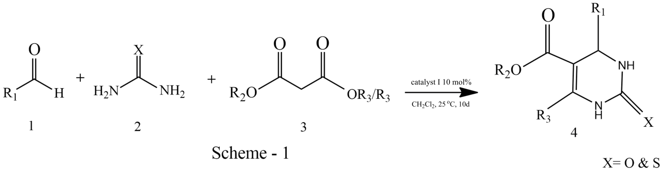

Scheme-6

Y. Guo et al. evaluated several chiral phosphoric acid for the enantioselective Biginelli reaction of aliphatic aldehydes (Scheme-6) with a chiral phosphoric acid derived from 3,3′-bis(3,5-di-tert-butyl-4-methoxyphenyl)-1,1′-binaphthalene-2,2′-diol. Initially, the catalytic asymmetric Biginelli reaction of 3-phenylpropanal, thiourea, and methyl acetoacetate was carried out in the presence of 10mol% of the H8-binol-based phosphoric acid at 25°C in CH2Cl2. The reaction gave DHPMs in 2% yield with 65% ee11.

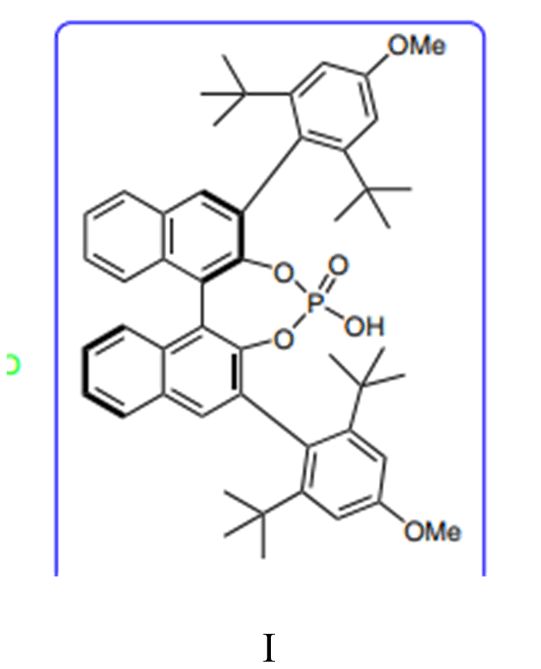

Figure-2

To optimize the reaction conditions further, the effects of temperature was investigated, and it was found that lowering the reaction temperature to 15 °C did not improve the enantioselectivity and the reaction became sluggish. Although a significantly improved yield was obtained by increasing the reaction temperature to 35 °C, the enantioselectivity decreased significantly. In addition, when the reaction temperature was increased to 50 °C, the yield and enantioselectivity both fell dramatically. The use of 10 mol% of (fig-2) in CH2Cl2 was effective in pushing this reaction forward, and the addition of larger amounts of the catalyst did not improve the yield. In general, the side chains and the length of the carbon chain of the aliphatic aldehydes had a marked influence on the enantioselectivity of the reaction11.

1. **Biginelli Reaction: Polymer Supported Catalytic Approaches**

A study of the literature reveals that some research groups have reported solid-phase synthetic protocols for synthesis of bioactive heterocyclic compounds12. This approach involves one of the components of the reaction attached to polymer support and after completion of reaction, detachment of product moiety from the support (Fig3). These kinds of solid-supported strategies involve very simple workup processes and have produced diversely substituted DHPMs of high purity without need of chromatographic techniques. The polymeric supports were recycled for many times without losing their efficiency12.

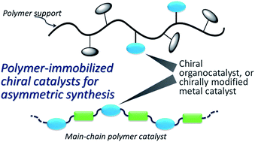

Figure-3

* **Organic Polymers and Copolymers as Catalyst.**

1. Pourjavadi et al. reported poly(2-acrylamido-2-methylpropane sulfonic acid, AMPS) cross-linked with N,N′-methylene bisacrylamide (MBA) copolymer as efficient catalyst for Biginelli reaction. Optimized reaction conditions were mild, involved product isolation by simple filtration, which separates the solid polymer, and concentration of the filtrate to afford products. The polymeric catalyst was reused for three times with negligible loss in activity13.
2. Khiratkar et al. synthesized polymer-supported benzimidazolium based ionic liquid (PSBIL) as a Bronsted-acidic, heterogeneous organocatalyst for the Biginelli reaction. The yields of the resulting DHPMs were good to high but the temperature for an efficient. Conversion was higher compared to other reported methods with a thermal stability up to 334 °C marks the noticeable significance of PSBIL catalyst, which makes it more applicable for organic transformations involving higher temperatures14.
3. Elhamifar prepared and applied polyethylene-supported ionic liquid/iron complex as catalyst in synthesis of DHPMs under solvent free conditions. Yields were reported high to excellent. The recovered catalyst then reused for seven times more without loss in activity15.
4. Chegini et al. demonstrated the use of polyvinylpolypyrrolidone-supported chlorosulfonic acid [(PVPP−SO3H)+Cl−] as a catalyst for the Biginelli condensation. The polymer supported catalyst was found stable to 200 °C. The catalyst proved its efficiency with reduced reaction times and excellent yields of DHPMs16.
5. Recently, Patel and co-workers reported polyaniline supported FeCl3 (PANI−FeCl3) as an efficient heterogeneous Lewis acid catalyst for Biginelli reaction. The catalyst was prepared and characterized by usual analytical and spectral techniques17.

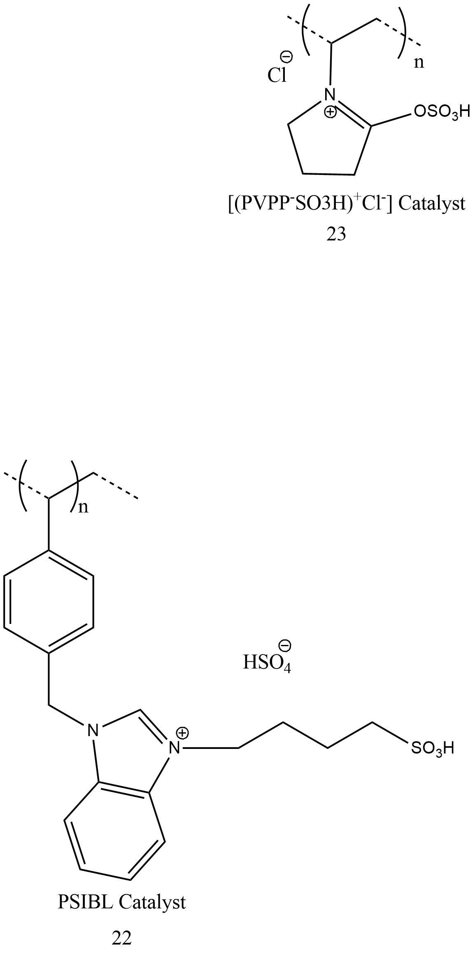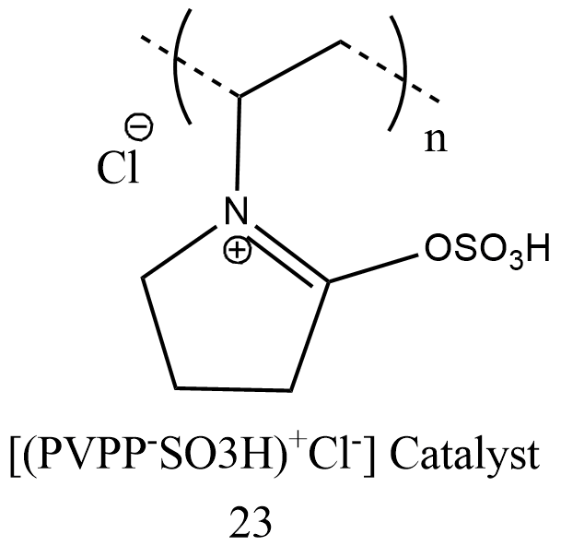

Figure-4

1. **Biginelli reaction on cellulose acetoacetate:**

Sui et al. have introduced a Biginelli-type modification of cellulose acetoacetate. Cellulose acetoacetate was chosen as the precursor for preparing DHPM derivatives with different functional groups. FT-IR, 1 H NMR, and solid-state 13C NMR were used to confirm both the formation of the DHPM structure and the reaction efficiency. The results suggested that more than 80% of the acetoacetyl groups were converted within four hours. The resulting products showed favorable thermal stability with the onset of degradation at approximately 260 °C and good solubility in selected solvents. Furthermore, the polymer mPEG (Poly(ethyleneglycol)) could also be grafted onto the cellulose chain using this method. Thus, the Biginelli reaction provided a simple, green, and modular route to synthesize selectively functionalized cellulose derivatives with diverse substrates, including various aldehydes, urea, thiourea18.

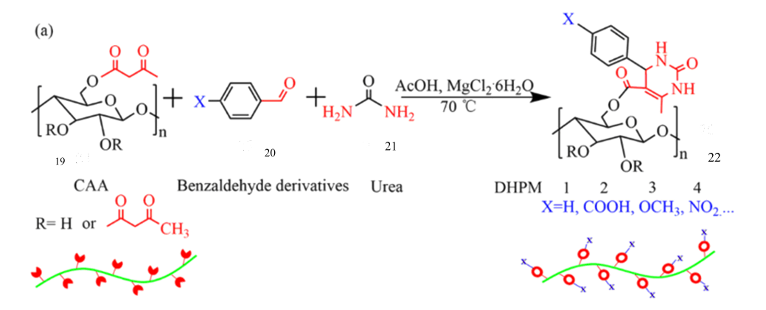

Scheme-7

* **Grafting mPEG onto CAA via the Biginelli reaction:**

Polymer grafting provides a means of altering the physical and chemical properties of cellulose and increasing its functionality. Previously cellulose grafted-PEG copolymers were prepared via a complicated process and applied in thermosensitive storage materials. However, development of simple and efficient methods for the introduction of PEG into the cellulose backbone has been challenging. As shown in (Scheme-7), mPEG was mildly esterified with 4-formylbenzoic acid. The resulting product was referred to as CHO-mPEG. The TGA and DTG data (Fig.5) showed that the thermal stability curves of DHPM-5 had characteristics of both CAA and mPEG. DHPM-5 had a two-stage decomposition process19. First, the cellulose backbone began to decompose at 210 °C; when the temperature reached 350 °C, the mPEG sidechain decomposed with increasing temperature. As a result, two peaks were observed in the DTG of DHPM-5, corresponding to the maximum rates of thermal decomposition for CAA and CHO-mPEG. Besides, the glass transition peak of the grafted mPEG on DHPM-5 was observed in the DSC heating curves of DHPM-5, neat CAA and CHO-mPEG. These results illustrated the successful modification of CAA chains with polymer through the facile and efficient Biginelli reaction19.

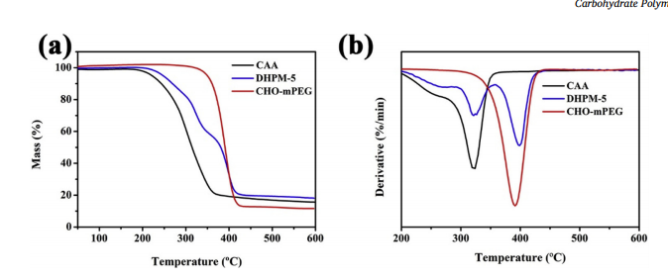

Figure-5

1. **Modification of Starch via the Biginelli Multicomponent Reaction:**

Eren et el investigated the synthesis and characterization of modified starch products by first synthesizing starch acetoacetate (SAA) and subsequently modifying it with different renewable components (such as benzaldehyde, vanillin, and p-anisaldehyde) in a sustainable fashion by applying the Biginelli multicomponent reaction20. In this work, a Biginelli type modification of starch was reported by first acetoacetylating starch with a high degree of substitution and further reacting it with urea and various renewable and commercially available aldehyde derivatives to demonstrate the versatility of this multicomponent reaction approach (Scheme-8). A straightforward and versatile starch modification under metal-free and considerably mild condition21.

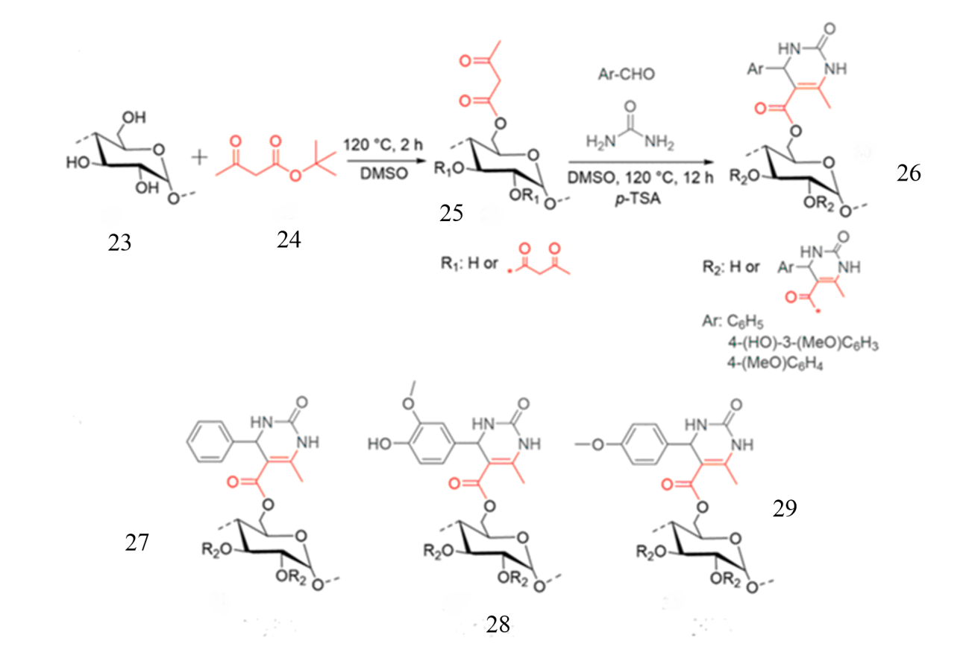

Scheme-8

Additionally, acetoacetylated starch samples showed thermoplastic behavior with a wide range of Tg values (93–131°C), depending on the degree of substitution. After the Biginelli modification, products with high molecular weight and high thermal stability were obtained. It could also demonstrate that the Biginelli modified starches required glycerol as a plasticizer to be processed20.

1. **High Throughput Preparation of UV-Protective Polymers from Essential Oil Extracts via the Biginelli Reaction:**

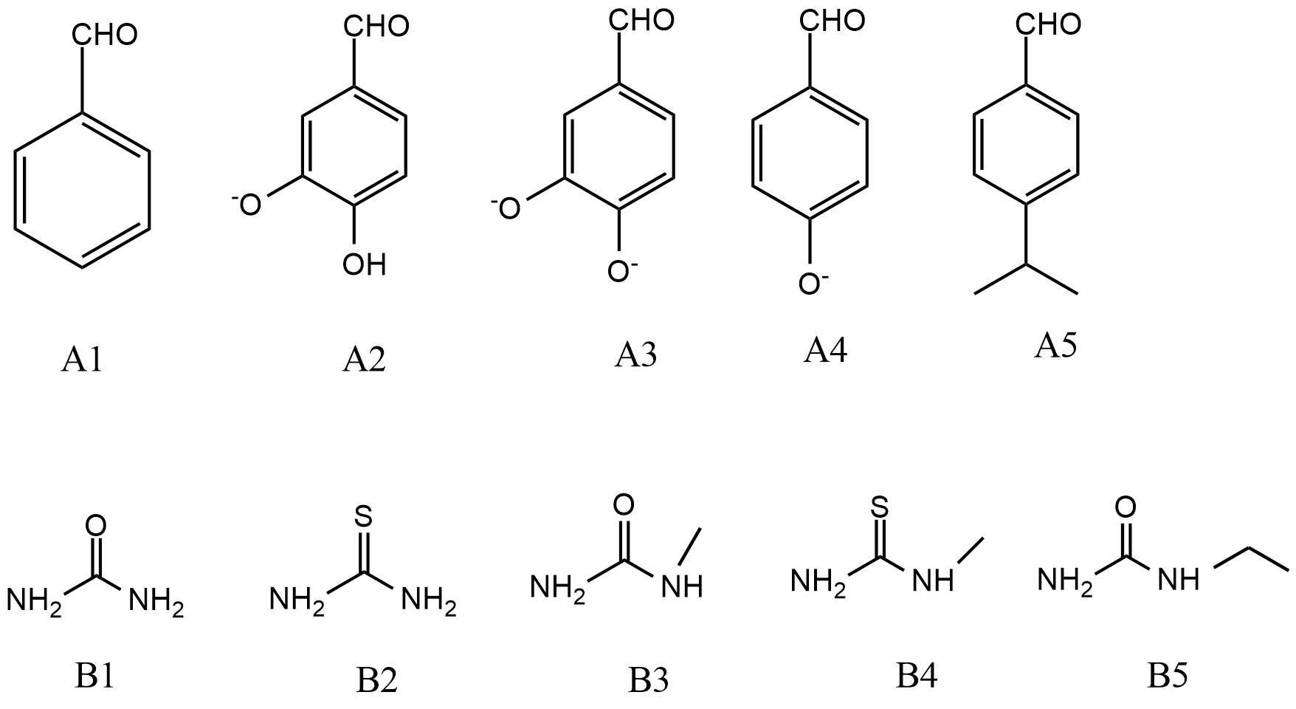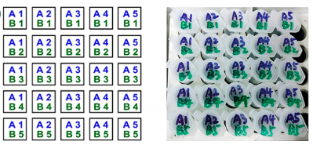

Figure-6

Figure-6

Gou et el high throughput (HTP) system has been developed to exploit new functional polymers. They synthesized 25 monomers in a mini-HTP manner through the tricomponent Biginelli reaction with high yields21(Fig.6). The starting materials were five aldehydes extracted from essential oils. These monomers were then used for radical polymerization to simultaneously obtain 25 polymers with different Biginelli structures as the side chains22. They tried HTP analyses to evaluate the specific bioactivity of the resulting polymers and obtained a biocompatible polymer that protects cells from UV damage. This demonstrates the utility of the HTP strategy to optimize and screen functional polymers for possible practical application23.

Aromatic aldehydes (EOs extracts) were used to convert the commercially available monomer 2-(acetoacetoxy)-ethylmethacrylate (AEMA) to new monomers via the Biginelli reaction. The monomers were synthesized in a HTP manner by mixing 5 aromatic aldehydes (A(X)) and 5 (thio)urea compounds (B(Y)) through different combinations (5 × 5) to simultaneously create 25 Biginelli-monomers (M(X)(Y)21.

* In a typical reaction, AEMA, A(X), and B(Y) were added to centrifuge tubes, and the molar ratio of each component was set as AEMA:A(X):B(Y) = 1:1:1.5. The excess urea/thiourea compounds were added to ensure complete reaction of the β-ketoester group in AEMA. Acetic acid and MgCl2 (20 mol % with respect to aldehydes) were used as the solvent and catalyst, respectively. The 25 tubes were charged with reactants, solvent, and catalyst and kept in a 100 °C isothermal shaker for 2 h21.
* **Cytotoxicity Evaluation**: UV light is known to destroy DNA through radical processes. thus, the ability of copolymers to protect cells from UV damage was also evaluated because of the excellent radical-fighting DHPM groups on their chains. When incubated, most cells (86−98%) lost viability after UV irradiation, but there was 47−74% viability with 2 mg/mL of copolymers and exposure to UV light. This indicates that the DHPM side groups in the copolymers protect cells from the UV light. These polymers (Scheme-9) were tested against SOD to see if they can act as sunscreen and after 30min of UV exposure the cells containing polymer shown very less damage although the cells cultured with SOD indicated the poor protection of SOD to cells24.

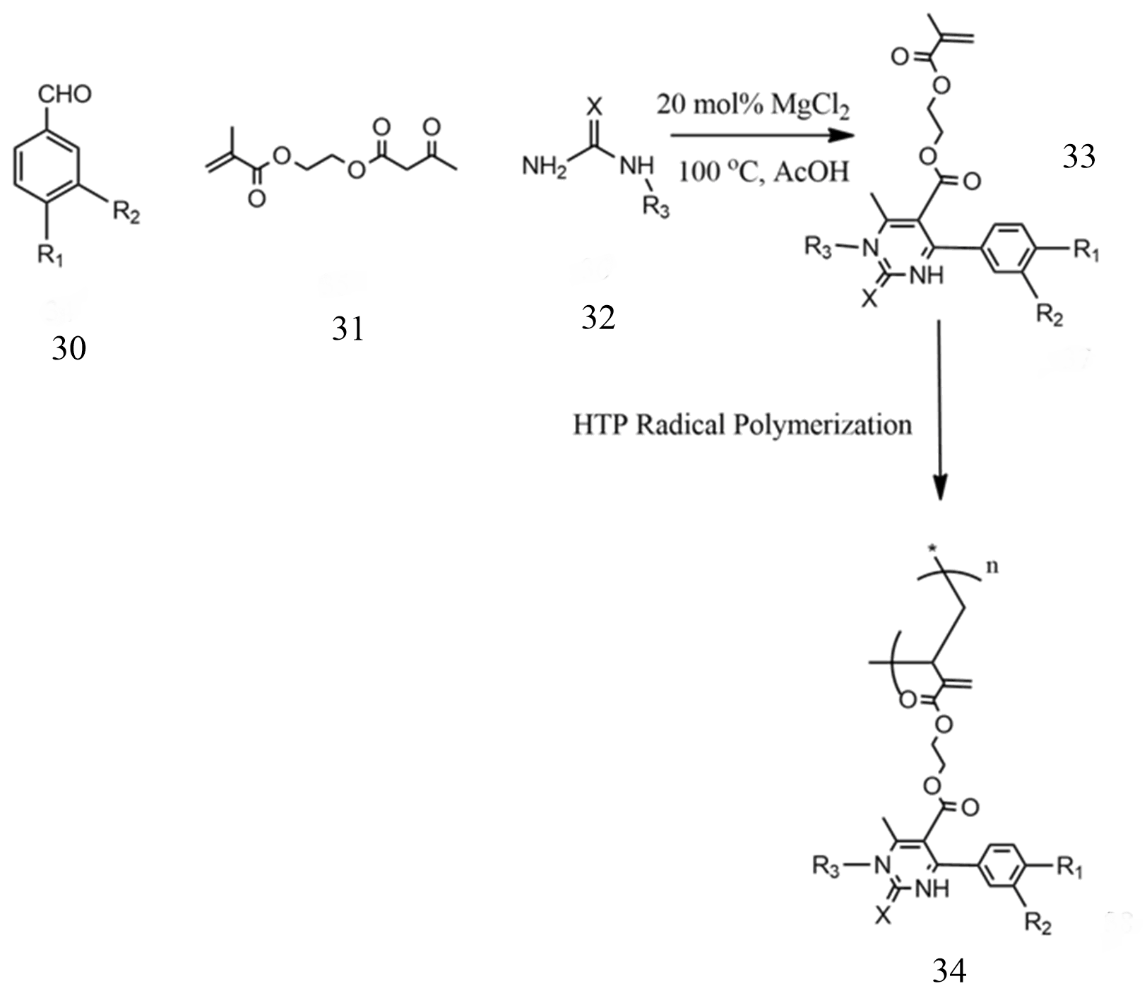

Scheme-9

1. **Versatility of the Biginelli reaction: Synthesis of new biphenyl dihydropyrimidin-2-thiones using different ketones as building blocks:**

Eifler-Lima et el demonstrated the synthesis of DHMPs using four different ketones and three aldehydes with 1-phenylthiourea. The aim of obtaining structural diversity in DHPM scaffolds, chemical diversity in the library was achieved by using the versatility of the Biginelli reaction through exploration of variations at the C-5 position of the biphenyl dihydropyrimidin-2-thione core, using ketones as building blocks instead of a beta-ketoester25. Thus, using four different ketones 35-38 (Fig.7) and three aldehydes 40-42 in the Biginelli reaction, with 1-phenylthiourea 39, under mild conditions, it was possible to create a small focused library of 12 DHPMs 47-58 with a good chemical and structural variety and purity26.

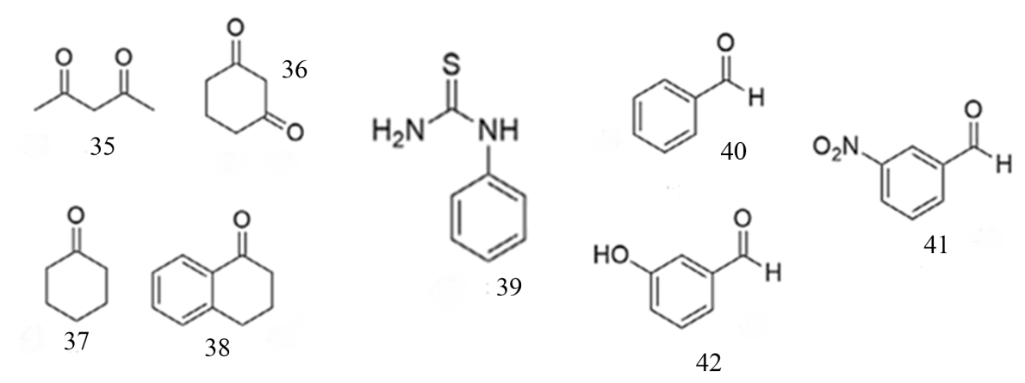

Figure-7

The current study also aimed at obtaining the compound 46, by use of 2 equivalents of benzaldehyde 43 (Scheme-10). The reaction in urea with 2 equivalents of aromatic aldehyde and a cycloalkanone has previously been reported as a strategy for accessing DHPMs with structures like compound 46, without substitution at N1. However, under the employed reaction conditions, only compound 45 was obtained27.

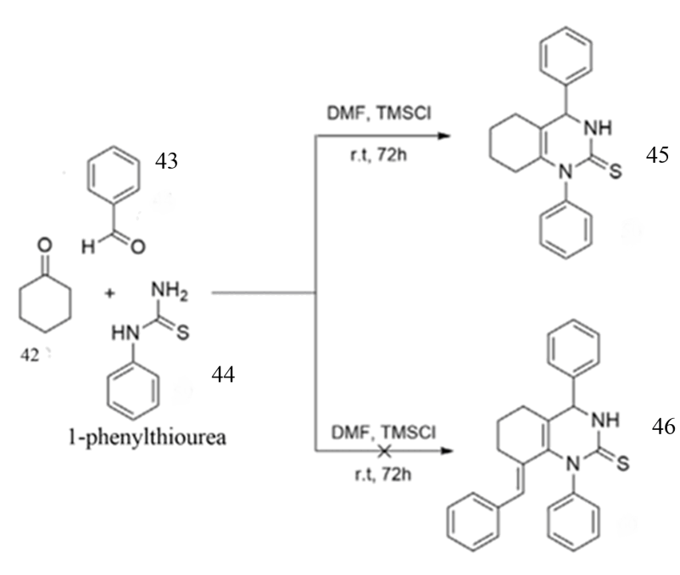

Scheme-10

1. **Biological activity of DHPMs:**

Due to the versatility of the Biginelli reaction, an infinity of products can be obtained in a very simple and direct way using this MCR with the proper reagent selection28.

1. **Anticancer activity:**

Cancer is a set of diseases characterized by disorderly cell growth, often with the ability to invade health tissues and organs29. Monastrol, discovered in 199930 is a small cell-permeable and central DHPM derivative, which is useful as a prototype for the development of anticancer drugs. Its action is on kinesin Eg5 (a motor protein) of mitotic cells, inducing monoastral spindle instead of the bipolar spindle during cell division. Some synthesized compounds showed inhibitory activity on Eg5 and impaired the mitosis of tumor cells. They also decreased the cancer stem cells (CSC) in MDA-MB-231 cells, restraining tumor initiation and maintenance. Compounds (Fig. 8) were secure for fibroblasts, being selective for cancer cells31.

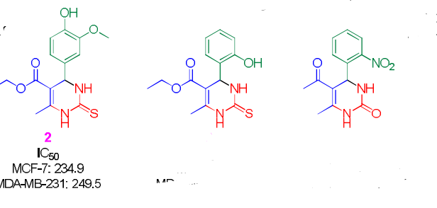

Figure-8

1. **Antimicrobial activity**:

Elumalai and co-workers32 studied some DHPM derivatives (Fig.9) with antimycobacterial activity. In the work, researchers used two pharmacophoric hybridized groups (2,4,5,6-pyrimidine and DHPM) to synthesize a set of new molecules31.

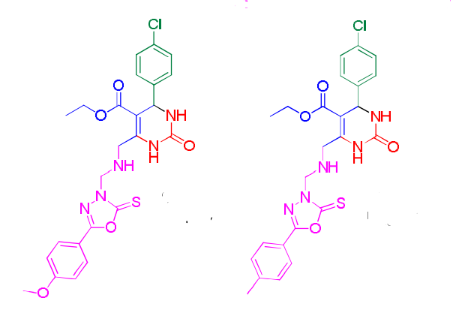

Figure-9

1. **Anti-HIV activity:**

Kim and co-workers’ report33 of activity and preliminary structure-activity relationship (SAR) of DHPMs (Fig.10) as inhibitors of HIV-1 replication34. The synthesis of compounds was performed by the Biginelli reaction. The conclusion of this evaluation is that a non-polar bulky R group is necessary to anti-HIV activity. An increase in the size of R2 from methyl to ethyl and propyl showed improved cellular activity from 0.529 µM from methyl (26) to 0.087 from ethyl (28) and 0.286 µM to propyl (29). The other analogs exhibited reduced or complete loss of activities31.

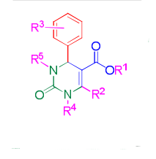

Figure-10

1. **Calcium channel blockers (CCBs):**

Chakraborty and co-workers108 reported CCB activity of DHPMs34(Fig. 11) with or without a N1-alkyl substitution. This study revealed that substitution in this position abolishes calcium channel inhibition, and perhaps the hydrogen bonding at this position is essential to the activity. The most active conformers were those with substituent of phenyl group syn-periplanar with C-4 hydrogen and ester in the S-cis conformation for maximum receptor affinity35.

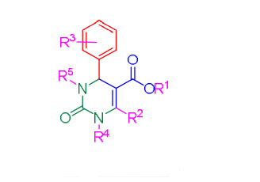

**CONCLUSION**

Figure 11

This report constitutes the synthesis method of Dihydropyrimidinones by using biginelli reaction in a very short reaction time. I conclude that there are various pathways that have been accounted for the synthesis of Biginelli adducts. Even though many methodologies have been reported still there is great scope to develop new methods. The most employed synthetic pathways are solvent-free based. The role of catalysis is vital to the synthesis of DHPMs, not only to improve yields and to shorten times, but also to select a proper reaction pathway. Enantioselective versions are now emerging, but there is still plenty of room for improvement in the reaction conditions, yields, ee values and mechanistic studies. We could synthesize a huge number of polymers and biginelli aducts which are of great importance in medicinal chemistry.

**Refrences:**

1. Domling, A.; Wang, W.; Wang, K. Chem. Rev. 2012, 112, 3083.
2. M. Barbero, S. Cadamuro, S. Dughera,A Brønsted acid catalyzed enantioselective Biginelli reaction, Green Chem., 2017, 19, 1529–1535 | 1529
3. S. Sheik Mansoor, S. Syed Shafi, S. Zaheer Ahmed, Arab. J. Chem. 2016, 9, S846–S851
4. Chikhale, R. V.; Bhole, R. P.; Khedekar, P. B.; Bhusari, K. P. Eur. J. Med. Chem. 2009, 44, 3645.
5. Z.-L. Zhou, P.-C. Wang, M. Lu, Chin. Chem. Lett. 2016, 27, 226–230
6. J. Peng, Y. Deng / Tetrahedron Letters 42 (2001) 5917–5919
7. M Barbero, S. Cadamuro and S. Dughera. Green Chem., 2017, 19, 1529–1535
8. Huang, F. Yang and C. Zhu, J. Am. Chem. Soc., 2005, 127, 16386
9. Olga V. Fedorova1,3 • Yulia A. Titova1,3 • Alexey Yu. Vigorov1 • Maria S. Toporova1 • Olga A. Alisienok2 • Anna N. Murashkevich2 • Victor P. Krasnov1 • Gennady L. Rusinov1,3 • Valery N. Charushin
10. Tanabe K (1970) Solid acids and bases. Their catalytic properties. Academic Press, New-York
11. Yongbiao Guo* Zhenhua Gao Xiangyan Meng Guilan Huang Hui Zhong Huilan Yu Xiaoqin Ding Hui Tang Chuanpin Zou, Georg Thieme Verlag Stuttgart · New York — Synlett 2017, 28, A–E
12. R. V. Patil, J. U. Chavan, D. S. Dalal, V. S. Shinde, A. G. Beldar, ACS Comb. Sci. 2019, 21, 105–148.
13. R. Velpula, J. Banothu, R. Gali, R. Deshineni, R. Bavantula, Chin. Chem. Lett. 2015, 26, 309–312.
14. Biginelli, P., 1893. Aldehyde-urea derivatives of aceto-and oxaloacetic acids. Gazz. chim. ital, 23(1): 360-413
15. Rajendra V. Patil, Jagdish U. Chavan, Dipak S. Dalal, Vaishali S. Shinde,and Anil G. Beldar, ACS Comb. Sci. 2019, 21, 105−148
16. Patil, R. V.; Chavan, J. U.; Beldar, A. G. Synthesis of aminothiazoles: polymer-supported approaches. RSC Adv. 2017, 7 (38), 23765−23778
17. Pourjavadi, A.; Salimi, H.; Barzegar, S.; Eftekhari-Sis, B. A Novel Polymeric Catalyst for One-Pot Synthesis of 3,4-Dihydropyrimidin-2- (1H)-ones via Biginelli Reaction. Acta Chim. Slov. 2007, 54 (1), 140−143
18. Khiratkar, A. G.; Muskawar, P. N.; Bhagat, P. R. Polymersupported benzimidazolium based ionic liquid: an efficient and reusable Brønsted acid catalyst for Biginelli reaction. RSC Adv. 2016, 6 (107), 105087−105093
19. Elhamifar, D.; Elhamifar, D.; Shojaeipoor, F. Synthesis, characterization and catalytic application of a novel polyethylenesupported Fe/ionic liquid complex. J. Mol. Catal. A: Chem. 2017, 426, 198−204
20. Chegini, M. G.; Mokhtary, M. PolyvinylpolypyrrolidoneSupported Chlorosulfonic Acid: An Efficient Catalyst for One-Pot Synthesis of Dihydropyrimidinones and Octahydroquinazolin-2, 5- diones. Polycyclic Aromat. Compd. 2017, 37 (1), 63−72
21. Tengfei Mao, Guoqiang Liu, Haibo Wu,Yen Wei, Yanzi Gou, Jun Wang, and Lei Tao: J. Am. Chem. Soc. XXXX, XXX, XXX−XXX.
22. P. G. Seligra, C. M. Jaramillo, L. Famá, S. Goyanes, Carbohydr. Polym. 2016, 138, 66
23. Eren Esen and Michael A. R. Meier,Modification of Starch via the Biginelli Multicomponent Reaction: Macromol. Rapid Commun. 2019, 1900375
24. S. Estevez-Areco, L. Guz, L. Famá, R. Candal, S. Goyanes, Food Hydrocolloids 2019, 96, 518.
25. Kappe, C. O. Acc. Chem. Res. 2000, 33 (12), 879−888
26. Kreye, O.; Turunc, O.; Sehlinger, A.; Rackwitz, J.; Meier, M. A. R. Chem. - Eur. J. 2012, 18 (18), 5767−5776.
27. Itamar Luís Gonçalves a , Leonardo Davi a , Liliana Rockenbach a , Gustavo Machado das Neves a , Luciano Porto Kagami a , Rômulo Faria Santos Canto c , Fabrício Figueiró b , Ana Maria Oliveira Battastini b , Vera Lucia Eifler-Lima, Tetrahedron Letters 59 (2018) 2759–2762
28. Goncalves, I. L.; Davi, L.; Rockenbach, L.; das Neves, G. M.; Kagami, L. P.; Santos Canto, R. F.; Figueiro, F.; Oliveira Battastini, A. M.; Eifler-Lima, V. L. Tetrahedron Lett. 2018, 59, 2759
29. Siegel, R. L.; Miller, K. D.; Jemal, A. CA Cancer J. Clin. 2018, 68, 7
30. Mayer, T. U.; Kapoor, T. M.; Haggarty, S. J.; King, R. W.; Schreiber, S. L.; Mitchison, T. J. Science 1999, 286, 971
31. Brenno A. D. Neto,* Talita de A. Fernandes, Mauro V. Correia
32. Elumalai, K.; Ali, M. A.; Elumalai, M.; Eluri, K.; Srinivasan, S. J. Pharm. Res. 2013, 7, 241.
33. Kim, J.; Park, C.; Ok, T.; So, W.; Jo, M.; Seo, M.; Kim, Y.; Sohn, J.-H.; Park, Y.; Ju, M. K.; Kim, J.; Han, S.-J.; Kim, T.-H.; Cechetto, J.; Nam, J.; Sommer, P.; No, Z. Bioorg. Med. Chem. Lett. 2012, 22, 2119
34. Putatunda, S.; Chakraborty, S.; Ghosh, S.; Nandi, P.; Chakraborty, S.; Sen, P. C.; Chakraborty, A. Eur. J. Med. Chem. 2012, 54, 223
35. Rovnyak, G. C.; Kimball, S. D.; Beyer, B.; Cucinotta, G.; Dimarco, J. D.; Gougoutas, J.; Hedberg, A.; Malley, M.; McCarthy, J. P.; Zhang, R. A.; Moreland, S. J. Med. Chem. 1995, 38, 119